Task 1: To Create Main Loop, Display Prompt, Read User Input, Handle Exit Conditions, Design Control Flow Diagram, Test Interactive Loop
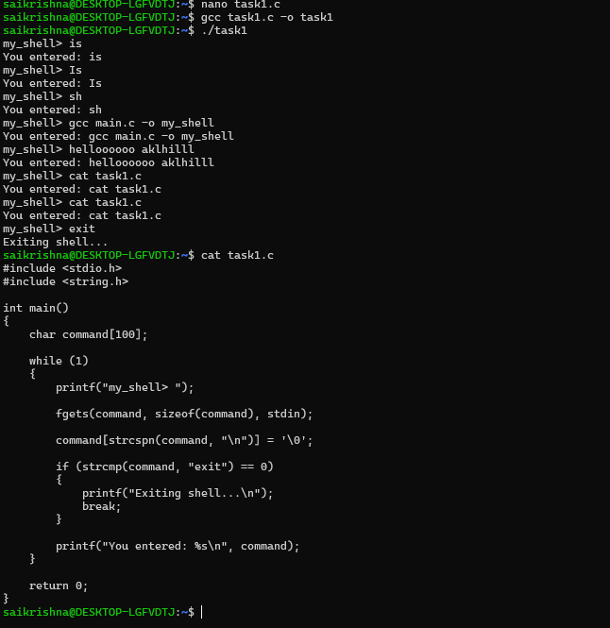
Task 2: Using the following system calls, copy the content from File1.txt to File2.txt.
- Open()
- Read()
- Write()
- Close()
open()
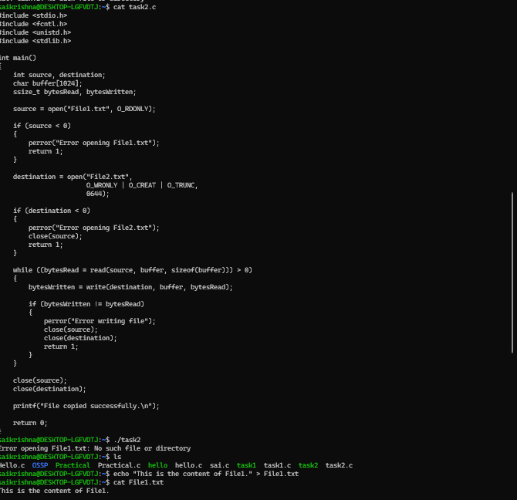
syntax: open(“ filename.txt”, modes, permissons)
Example: open(“First_Prgm.txt”, O_CREAT | O_WRONLY, 0644);

Table 1: Modes of Open system call
Flag | Purpose
O_RDONLY | Open for read only
O_WRONLY | Open for write only
O_RDWR | Open for both read and write
O_CREAT | Create file if it does not exist
O_TRUNC | Truncate (empty) an existing file
O_APPEND | Append data to the end of the file
O_EXCL | Fail if file already exists (used with O_CREAT)

read()
Syntax: read(int fd, void *buf, size_t count);
Example: read(fd, buffer, 100)
#include <stdio.h>
#include <unistd.h>
int main()
{
char buffer[100];
int n;
printf("Enter some text: ");
n = read(0, buffer, sizeof(buffer) - 1);
buffer[n] = '\0'; // Null-terminate the string
printf("You entered: %s", buffer);
return 0;
}

write()
Syntax: write(int fd, const void *buf, size_t count);
Example: write(fd, message, 11);
#include <unistd.h>
int main()
{
write(1, "Hello World\n", 12);
return 0;
}

Task 3: To Capture Keyboard Input, Handle Backspace, Process Enter Key, Manage Input Buffer, Support Multi-Character Commands, Test User Interaction.
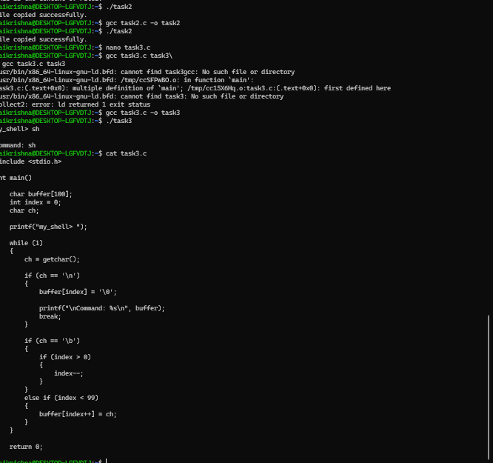
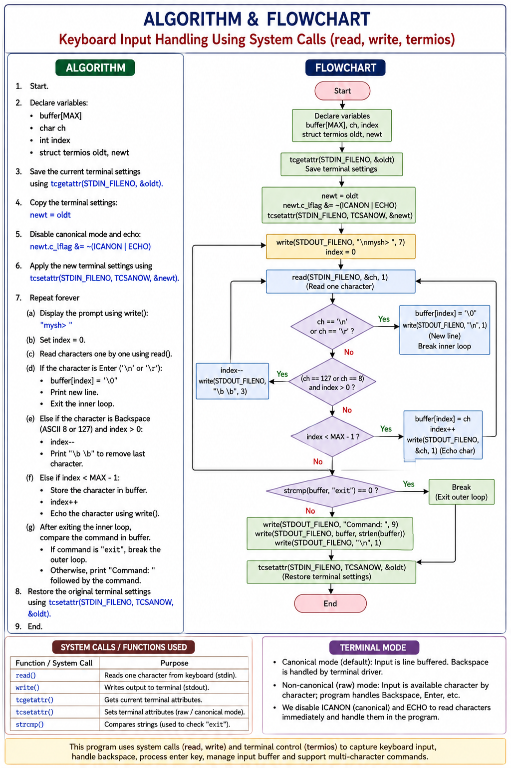
Task 4: To Apply Escape Sequences, Store Command History,
Navigate Previous Commands, Navigate Next Commands,
Update Input Buffer, Test Recall Functionality
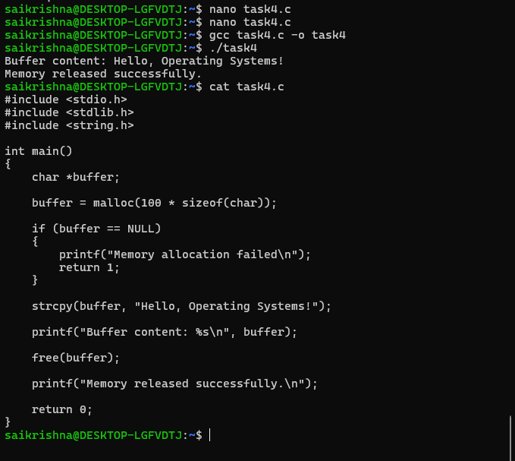
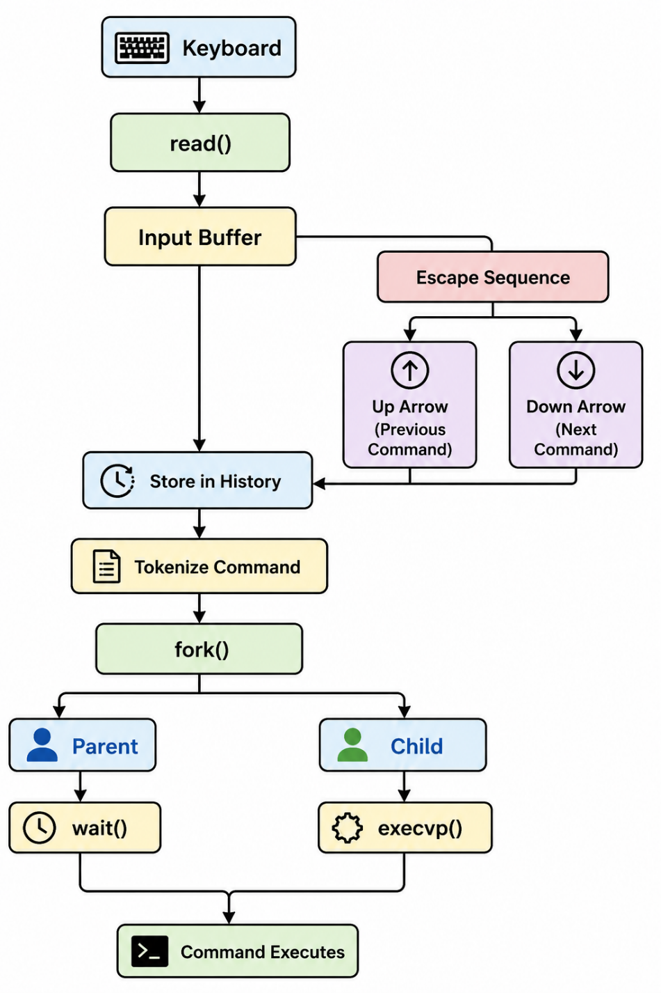

Task 5: To Allocate Buffers Dynamically, Resize Arrays, Prevent Buffer Overflow, Manage Linked Lists, Release Memory Correctly, Verify with Valgrind.
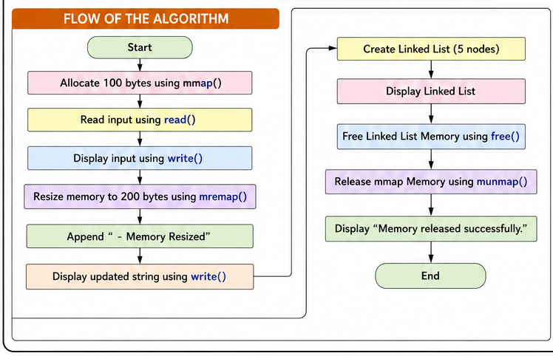
Validate the program with valgrind tool

